ServiceNow Script-Controlled ACL
Project Documentation format
1. Introduction
• Project Title: Script-Controlled ACL – Restrict Record Access Based on Field Value
• Team Leader: L. Amrin Begum
• Team Members: K. Bharathi, K. Dharshini Priya, T. Dharshini
2. Project Overview
• Purpose: To implement record-level access control in ServiceNow using an Access Control List (ACL), a field-based condition, and script-based authorization.
• Features: Restricts access to Institution Details records, evaluates the Branch field condition, applies scripted role authorization, and prevents unauthorized users from reading restricted records.
3. Architecture
• Platform: ServiceNow provides the application, security configuration, ACL evaluation, and record management.
• Access Control: A record-level Read ACL evaluates the configured Branch condition and advanced authorization script before allowing access.
• Data Table: The custom Institution Details table stores the records whose visibility is controlled by the ACL.
4. Setup Instructions
• Prerequisites: Access to a ServiceNow instance with permission to create tables, records, and ACLs.
• Installation: Create the Institution Details table and sample records, configure a Read ACL, add the Branch condition (EEE), and configure the Advanced ACL script.
5. Configuration Structure
• Table: Institution Details table containing the records used for access-control testing.
• ACL: Record-level Read ACL configured for the Institution Details table.
• Condition: Branch is EEE.
• Script: Advanced script checks the required role and returns true for authorized access; otherwise it denies access.
6. Running the Application
• Access the Instance: Log in to the ServiceNow instance and open the Institution Details table.
• Test Access: Request the target records and observe the ACL evaluation. Authorized users can access records when the configured security conditions are satisfied.
7. ACL / Security Documentation
• ACL Type: Record
• Operation: Read
• Condition: Branch is EEE
• Advanced Script: Uses the configured ServiceNow role check to allow authorized access and deny other users.

8. Authorization
• Role-Based Control: The advanced ACL script checks whether the current user has the configured role before granting access.
• Record Restriction: The Branch condition adds a record-level restriction so that access is evaluated against the target record.
• Access Result: If the ACL evaluation succeeds, the record is displayed; otherwise access is denied.
9. User Interface
• ServiceNow Interface: The project uses the standard ServiceNow interface for creating the table, records, ACL configuration, conditions, and advanced script.
• Evidence Screenshots: Screenshots can be included to show the configuration screens and the final access result.
10. Testing
• Functional Testing: Verify that the ACL allows access when the configured authorization requirements are satisfied and restricts access for unauthorized users.
• Condition Testing: Verify the Branch = EEE condition against the target records.
• Script Testing: Verify that the configured role check returns the expected allow or deny result.
11. Screenshots or Demo
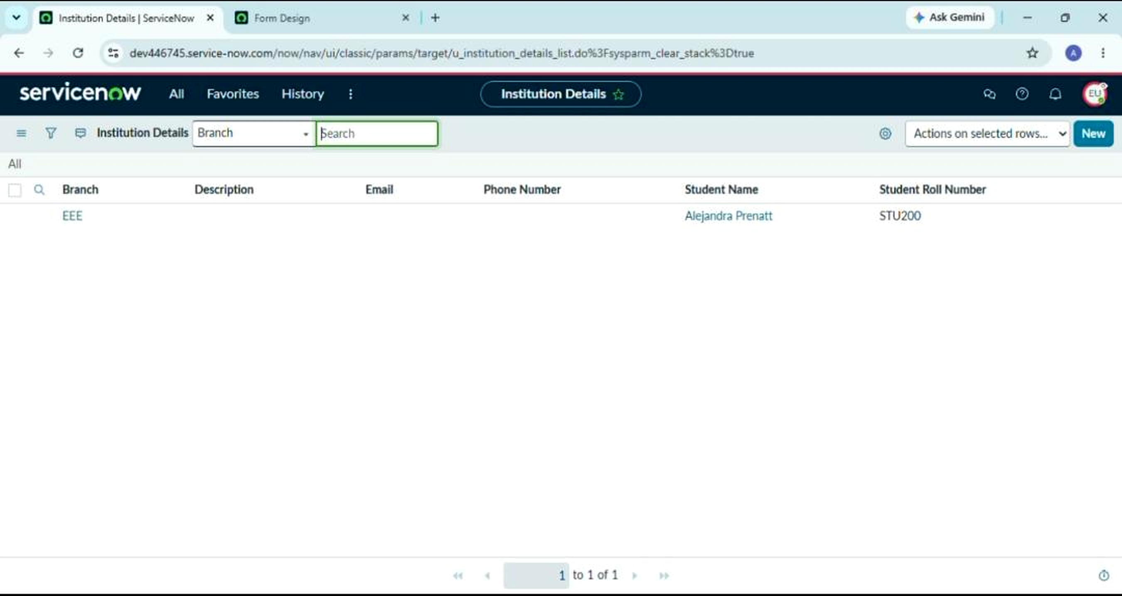
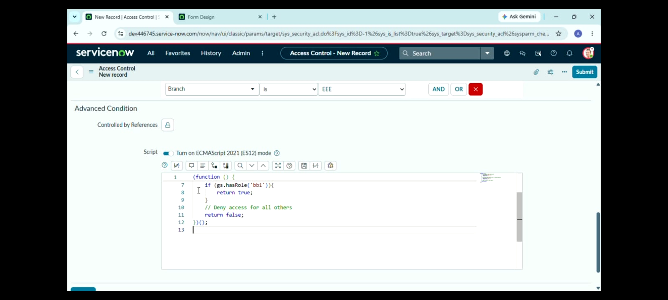

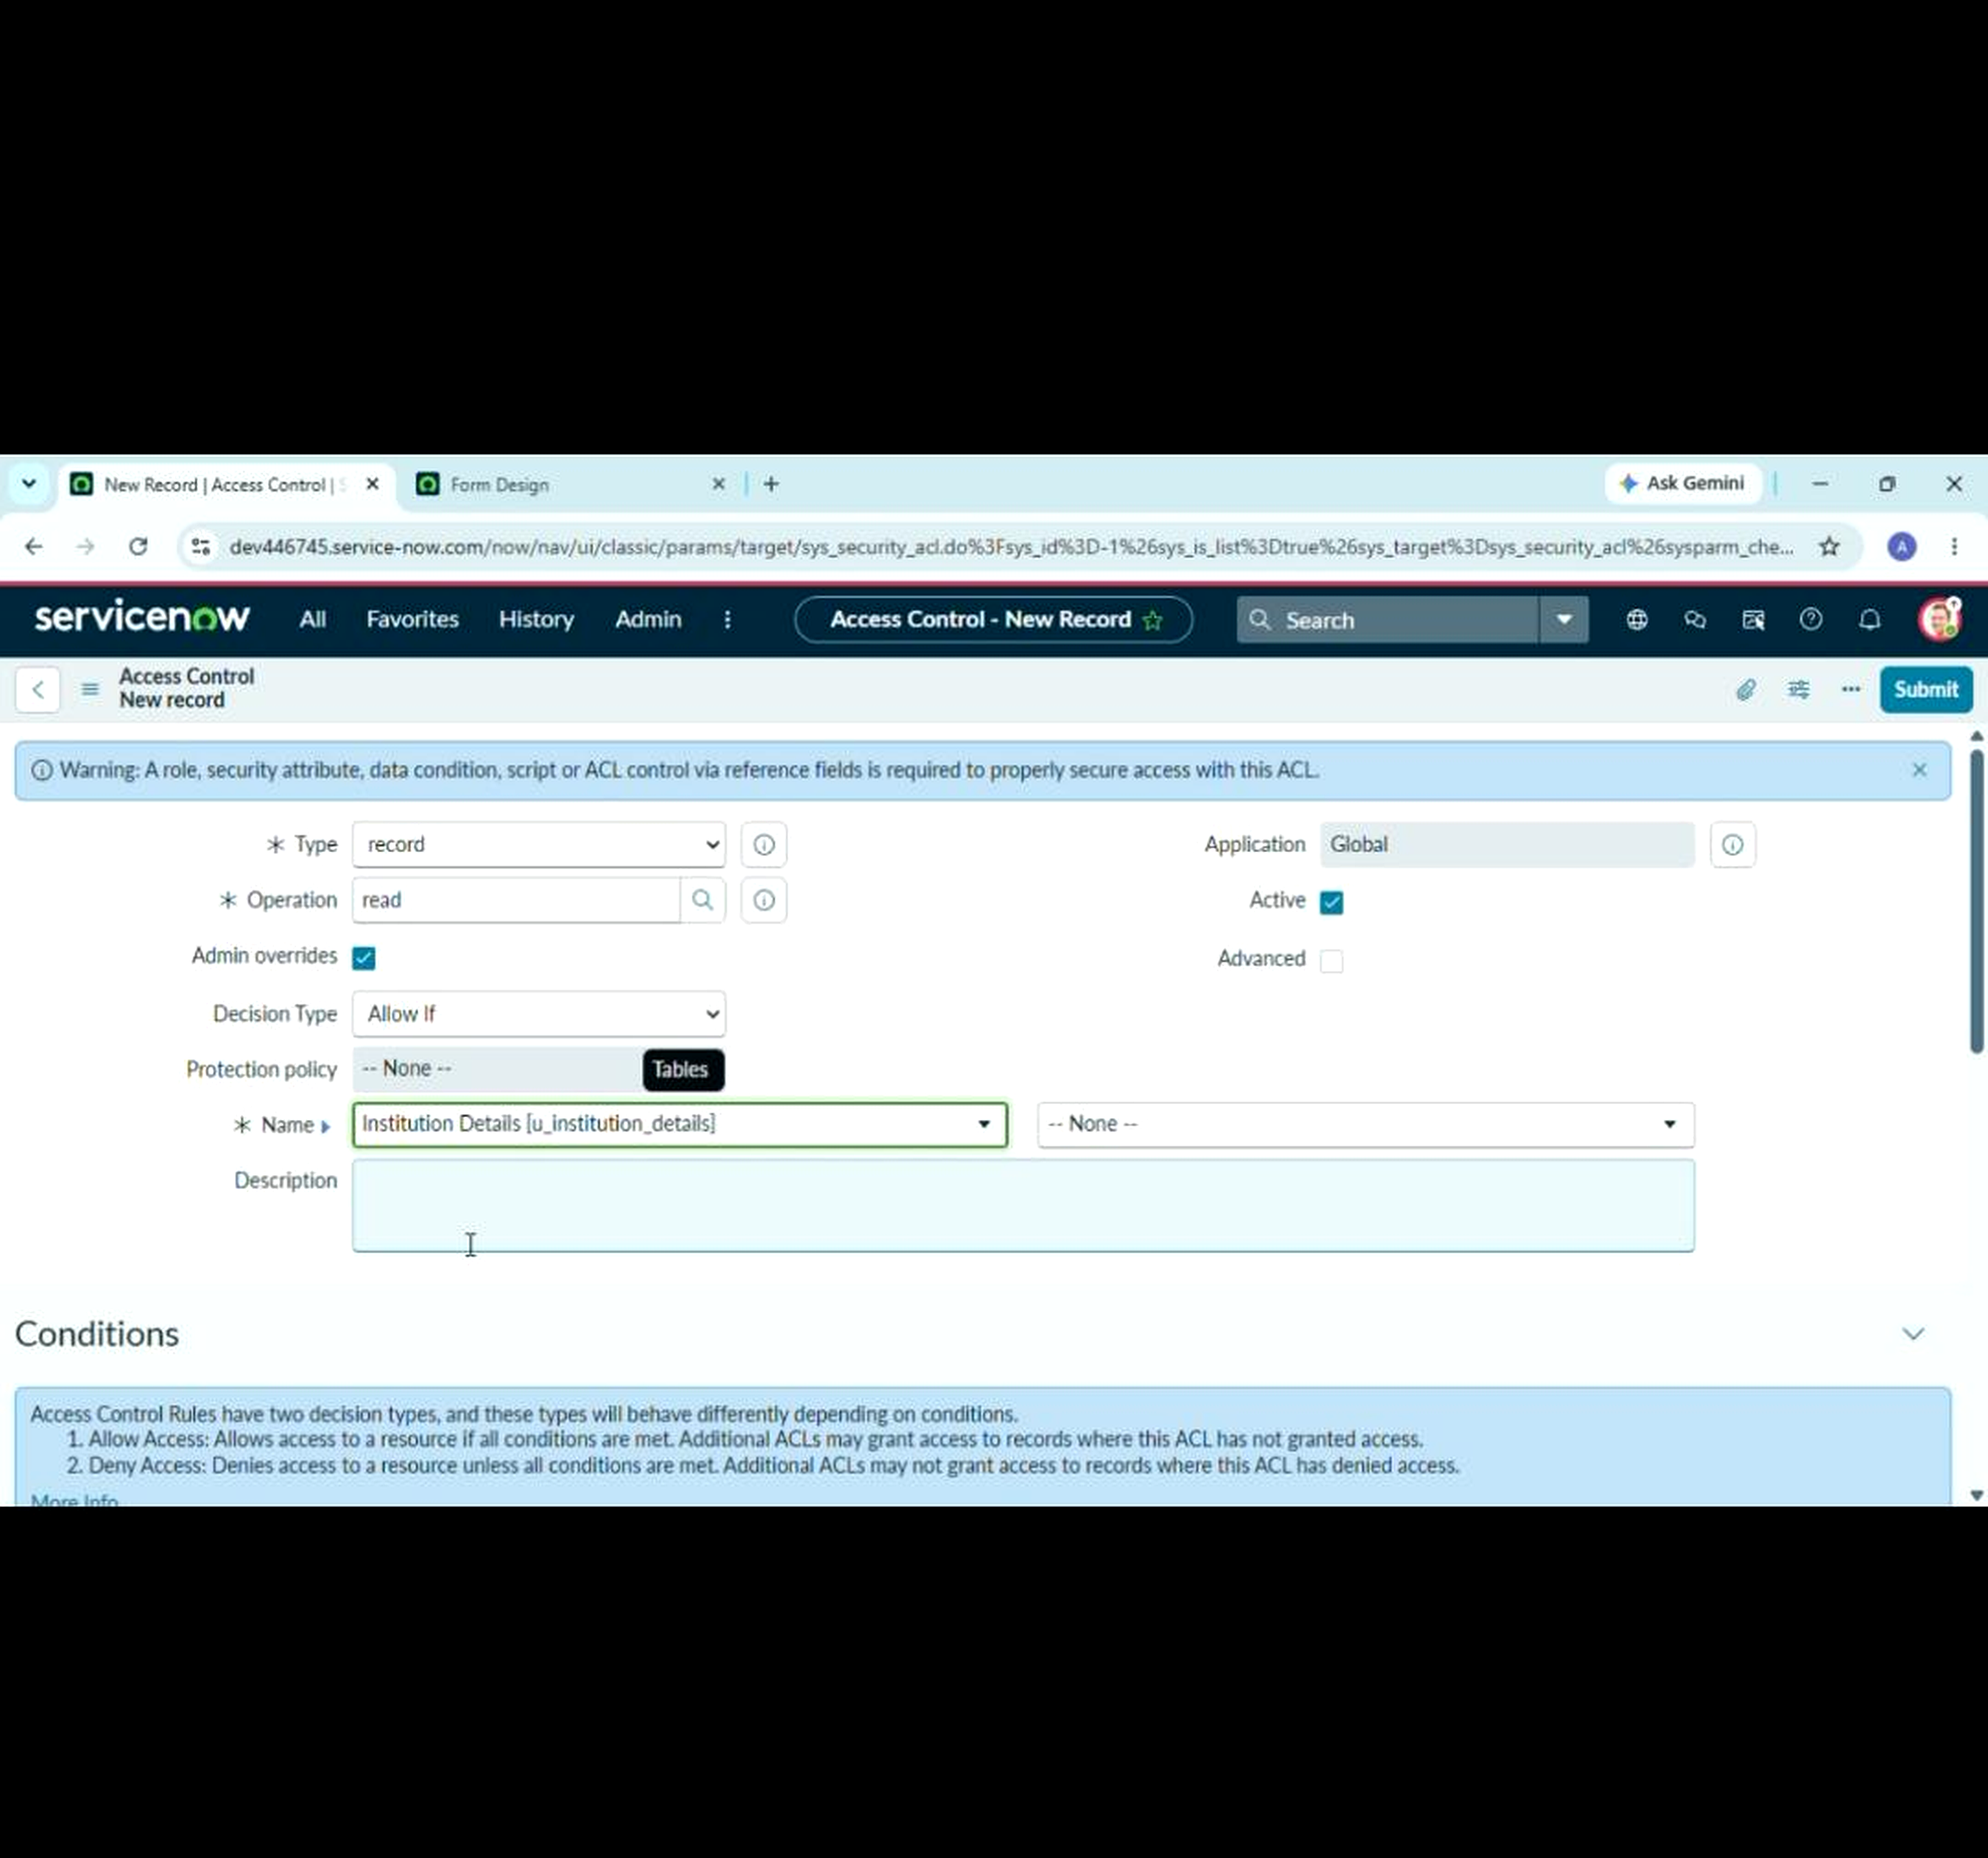

• Demo Link: https://drive.google.com/file/d/1BF0a-5ittC7Bxwb3czwaLBoVP7lvx2Y0/view?usp=drivesdk
12. Known Issues
• Configuration Dependency: Access behavior depends on the ACL configuration, user role, and target record values.
• Permission Dependency: Users without the required authorization may be unable to view restricted records, as intended.
13. Future Enhancements
• Dynamic Rules: Support multiple branch or department conditions through configurable security rules.
• Advanced Roles: Introduce more granular role and group-based authorization for different categories of records.
• Audit and Reporting: Add stronger access auditing and reporting to track denied and permitted record requests.
Project Links
• GitHub Repository: https://github.com/amrinbegum21122006-web/Script-Controlled-ACL-Restrict-Record-Access-Based-on-Field-Value

